**R Code for Examples in the book**

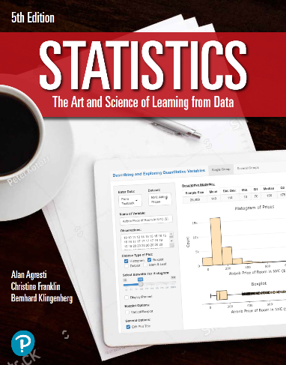

***“Statistics: The Art and Science of Learning from Data”***

**by Agresti, Franklin and Klingenberg, 5th edition**

**Chapter 15**

**Example 3: Driving Reaction Times – Wilcoxon Test: Finding Ranks**

## Reading in data:

reactionTimes <- read.csv(file='https://raw.githubusercontent.com/artofstat/data/master/Chapter15/reaction_time_long.csv')  
head(reactionTimes)

## Student group response  
## 1 1 control 557  
## 2 1 phone 636  
## 3 2 control 572  
## 4 2 phone 623  
## 5 3 control 457  
## 6 3 phone 615

## To assign ranks to the values

reactionTimes$Rank <- rank(reactionTimes $response)

## To subset the data

phoneRanks <- subset(reactionTimes, group == 'phone')$Rank  
controlRanks <- subset(reactionTimes, group == 'control')$Rank

## To perform a Wilcoxon test

wilcox.test(phoneRanks, controlRanks)

##   
## Wilcoxon rank sum test with continuity correction  
##   
## data: phoneRanks and controlRanks  
## W = 688, p-value = 0.01844  
## alternative hypothesis: true location shift is not equal to 0